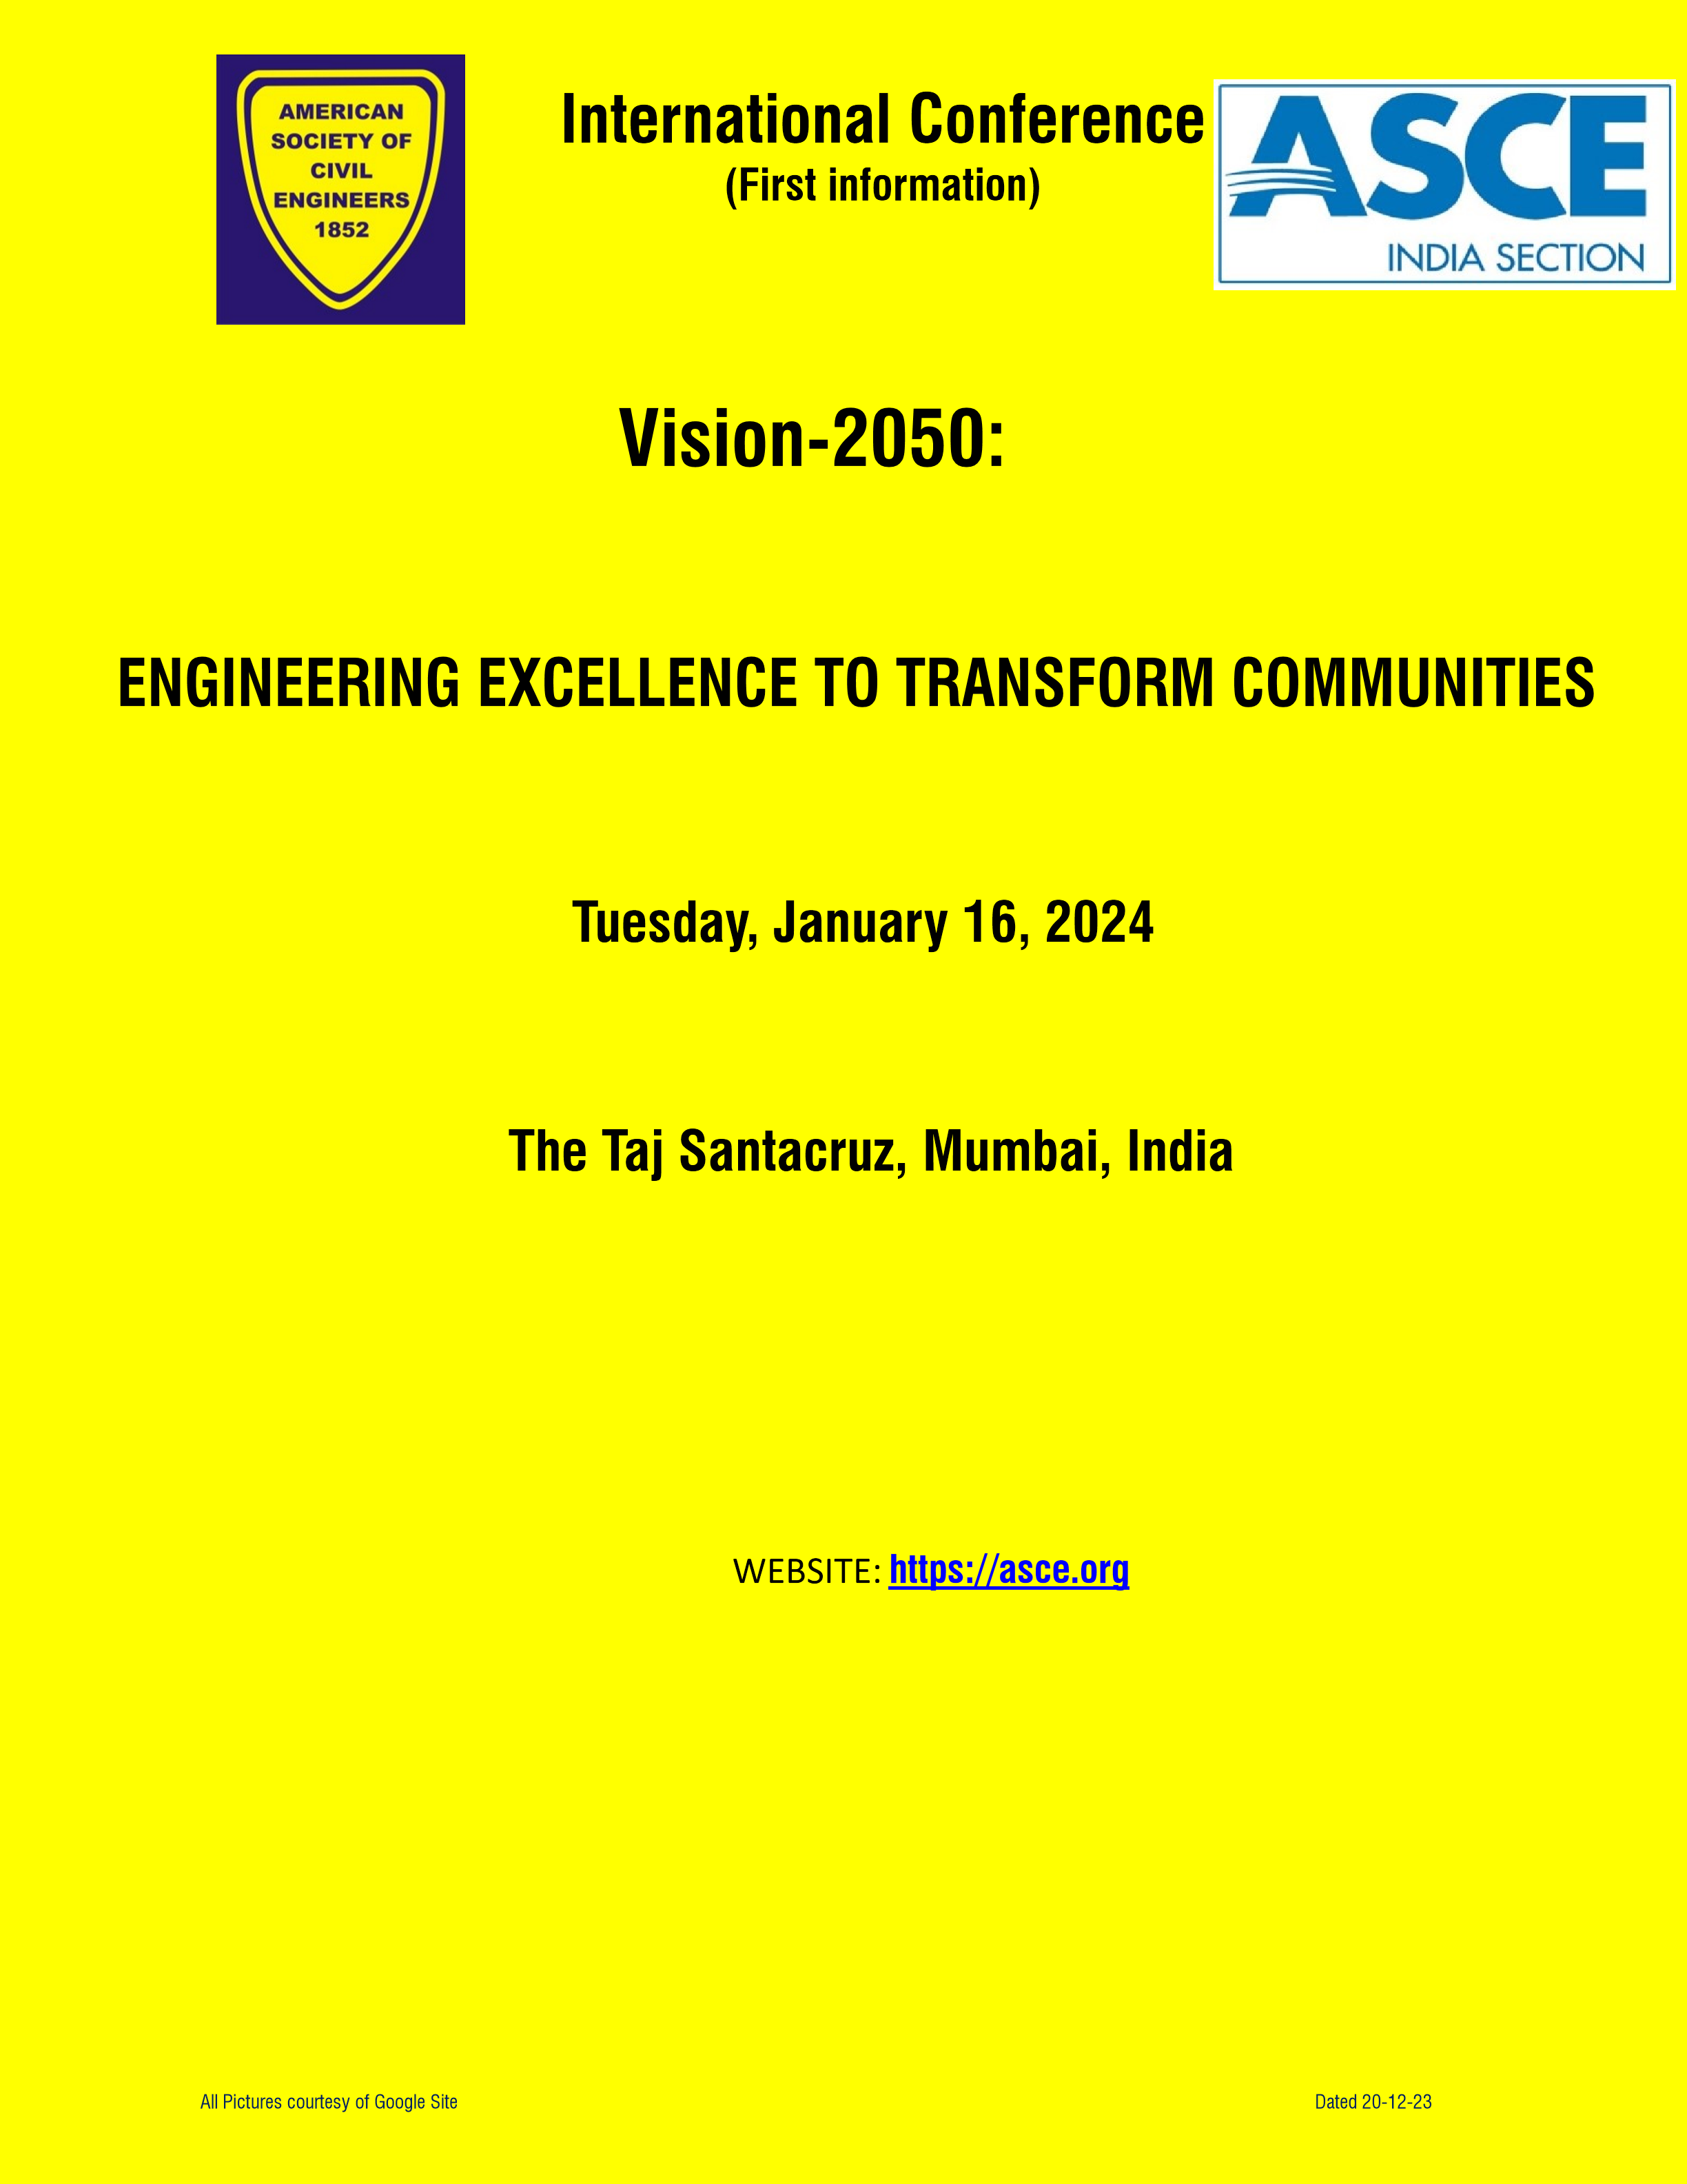

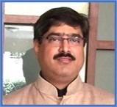
ASCE- INDIA SECTION PRESIDENT’S MESSAGE:

American Society of Civil Engineers’ (ASCE) Vision statement defines Civil Engineers as “Trusted leaders for a modern world”, entrusted by society to create a sustainable world and enhance the global quality of life for all while being good stewards of the natural environment and its resources. In addition, Civil Engineers are viewed as managers of risk and uncertainty caused by natural events, accidents and other threats. So, as we sit at the crossroads of having to address challenges such as climate change, preserving limited natural resources and improving the quality of life for all 10
billion that will inhabit this planet soon, we call home. We as leaders need to bring all those involved in the industry together.

This one-day international conference will do aforesaid, bringing visionaries, leaders, decision makers, funders, developers, planners, engineers, builders, maintainers from around the World to share their passion, vision, thoughts on how to “Build the World a-New”. Civil Engineers and those associated with infrastructure and environment need to take lead in this transformation, not only as providers of best solutions but also as Leaders, Managers and Stakeholders.

Please come join us on Jan. 16, 2024 at The Taj Santacruz, Mumbai.

Er. Ravindra J Ringshia (ME-Civil, USA)
President of ASCE – India Section
Corresponding Member, Board of Governors, of R10 of ASCE

ABOUT AMERICAN SOCIETY OF CIVIL ENGINEERS (ASCE) AND ASCE-INDIA SECTION
The American Society of Civil Engineers (ASCE) is the oldest Engineering Society founded in 1852 representing over 150,000 members in 177 countries. The India Section of the ASCE (ASCE-IS), with over 13,000 members, is the largest Section outside of North America. ASCE has 84 Agreements of Cooperation with engineering organizations in 66 countries and is the world’s largest publisher of civil engineering content, issues national and state-level infrastructure report cards and is an authoritative source for codes and standards that protect the public. Visit WWW.ASCE.ORG for more information and become a part of ASCE.

ABOUT THE CONFERENCE:

International Conference on “Vision 2050: Engineering excellence to transform Communities”
Tuesday, January 16, 2024, at The Taj Santacruz, Mumbai, India

The conference will bring together key stakeholders to explore ways to improve planning, financing, engineering, designing, constructing, maintaining and closure of infrastructure facilities in the face of climate and other disasters including future requirements.

Conference topics:
The Conference will elucidate on the current and future trends in the following spheres of the Civil Engineering:
- Engineering Excellence - Innovative engineering, construction technology, materials, tools and processes, etc.
- 21st Centure mobility- High speed mass transportation, Airports, Water and Road transportations, etc.
- Delivering Timeless Heritage including repair technology.
- Smart Communities/cities.
- Infrastructure- Sustainable, Resilience, Report Card, etc.
- Engineering standards and guidance.
- Finance and legal- Policy, regulatory, etc.

The Conference will also provide direction on how policy/regulatory work of financial institutions and multilateral development banks (MDBs) with the government, and their own procurement policies and practices can ensure “quality infrastructure” for climate action, specifically through engagement with professional bodies such as ASCE in the infrastructure sectors.

Invited Dignitaries:
- Senator Hon’ble Dr. Rosa Galvez, Canada has accepted our invitation to grace the conference as chief Guest.
- Dr. KN Gunalan, Chair-WFEO-United Nation Relations Committee has accepted our invitation to be a Keynote Speaker and Patron of the conference.
- We have also invited high lever representative of Government of India.

Expert Spearkers are:
Title | Expert Speaker
MTHL Overview | Mr. SA Wandhekar, EIC, MMRDA
Mumbai Coastal Road | Er. MM Swami-Ch.Engg+Dr. Vishal Thombare-EE, MCGM
Excellence in Project Engineering | Mr. Y. Sakhalkar, SE, MMRDA
Excellence in Construction & Project Management | Mr. A. Bhisikar, SE, MMRDA
Bullet Train Project - Quality Control Systems | Mr Deepak Gaikwad, L&T
Innovation for Engineering Excellence | Prof. Makrand Hastak, Purdue Univ, USA
Moragolla Hydropower Project | Dr Kamal Laksiri, Srilanka
Preserving Rashtrapati Bhavan | Prof. Arun Menon, IIT Madras
Preservation: Engineering Considerations | Mr. Chetan Raikar, Structwel, Mumbai

Tentative Program:

Time Program
08:00 - 08:45 Registration + Breakfast Note: All are requested to be reach 09:00 - 11:00 Inauguration and Keynote Address. venue by 7:55 am for 11:00 - 11:30 Networking Tea/Coffee Break. registration + Breakfast.
11:30 - 12:45 Session 1 - Engineering Excellence.
12:45 - 13:45 Networking Lunch Break.
13:45 - 15:15 Session 2- 21st Century Mobility.
15:15 - 15:45 Networking Tea/Coffee Break.
15:45 - 16:45 Session 3- Delivering Timeless Heritage.
16:45 - 17:00 Concluding Session.

Who should attend:
- Central, State and Local Leaders • Financial Institutions
- Public Sector Employees • Corporate Sector Employees
- Engineers / Designers / Site Engineers and Supervisors • Architects / Town planners
- Academia / Research Institutions / Educational institutions • Technology providers
- Construction Managers, Paraprofessionals, Quality Personnel • Builders / Developers
- Equipment Manufacturer’s / Material Suppliers • Repair / Restoration / Maintenance Professional
- Students – future leaders

Registration:
Registration fee: All non-Indian delegates shall pay in INR as indicated below.

Delegate charges are as follows: | Early Bird till | After
 | Jan. 1, 2024 | Jan. 1, 2024
ASCE members | Rs. 3000 | Rs. 3500
For students (original ID needed on the day of the conference) | Rs. 1800 | Rs. 2000
Members from supporting associations. | Rs. 3500 | Rs. 4100
All other Delegates | Rs. 3900 | Rs. 4500

- Registration will be online. Click here for registration. or the link is: https://forms.gle/PiaQJyeYHRLzAweH7
- For any assistance kindly contact organizers at ASCEINDIA@GMAIL.COM/Contact no.+91 78388 63297 (only between 2-6 pm IST)
- Registration entitles delegate entry to the conference hall + Breakfast + Lunch + Tea/coffee only.
- It is delegates responsibility for all other items not included with the registration including stay, travel, food, etc.
- Registration of 5 or more delegates will be entitled for a fee as per fee for Members of Supporting Association.
- Pre-registration will close by 8 pm on Jan. 13, 2024 (India Time).
- Add Rs.1000 for on-site registration (i.e., after close of pre-registration). Due to limitation of seats, it is advisable for get pre-registered. On-site registration can be closed anytime by the organizers without any notice.
- Registration will complete only on clearance of payment into ASCE-IS account.
- Right of admission reserved with ASCE-IS.

Payment Details:
All payments shall be to “AMERICAN SOCIETY OF CIVIL ENGINEERS – India Section” only.
- Bank details:
Bank Name: State Bank of India.
Bank Address: Subhash Road, Vile Parle – East, Mumbai, India-400057
Account Number: 41924428454
Account Name: AMERICAN SOCIETY OF CIVIL ENGINEERS – India Section
IFSC: SBIN0017610 (for payments from within India)
SWIFT Code: SBININBB356 (for payments from outside India)

- Kindly deposit offline payment in any SBI branch near to you (Do not forget to mention ASCE-IS a/c no. 41924428454 at the back side of the instrument).

Cancelation Policy:
- 50% refund if cancelled on or before Jan. 6, 2023.
- No refund for cancellations after Jan. 6, 2023.

Sponsorship / support:

Note:
Description | Amt.-Rs. | Amt-$ | Complimentary  delegate | Participation  on a Panel | Standee  -  2  #  'x2'  4 | logo on back  drop | Table space  'x2'  4 | Del. Kit  insertion
Platinum Sponsor# | 1250000 | 20000 | 25 | yes | yes | yes | yes | yes
Gold Sponsor | 1000000 | 17500 | 20 | yes | yes | yes | yes | yes
Silver sponsor | 750000 | 13000 | 15 |  | yes | yes | yes | yes
Supporter | 400000 | 7250 | 5 |  | yes |  |  | yes
Delegate Kit 1 | 250000 | 4000 | 2 | compan y logo printed on back side |  |  |  | yes
Delegate Kit 2 | 75000 | 1750 | 1 |  |  |  |  | yes
- Sponsors will provide banners and all display/ promotion material/ Printing cost. Size of banners is maximum 4’x2’ subjected to change without notice. Sponsorship includes benefits as mention above only.
- Also, request to kindly nominate maximum number of delegates from your organization. • 5% discount on all sponsorship if full payment is done by 1-1-2024
- # = Will try for - Chair on dais during Inauguration session.
- For more details on sponsorship or for any assistance kindly contact the organizers at ASCEINDIA@GMAIL.COM / +91 78388 63297 (Ms. Neha: between 2 to 6pm India Time)

ORGANIZAING COMMITTEE:
Ms. April Lander, Director of R10 of ASCE, New Zealand.
Er. Yasser Fatehi, Secretary, ASCE-IS, Mumbai, India
Er. Tanmay Raje, Treasurer, ASCE-IS, Mumbai, India
Dr. Ravi Sinha, President, ASCE-ISWR, Mumbai, India Dr. H.A.S. Sandhu, President of ASCE-ISNR, India.

Er. Hiten Mahimutra, Secretary, ASCE-ISWR, Mumbai, India. Dr. Elias B Sayah, Past Director, R10-ASCE, UAE.

Mr. Chetan Raikar, MD-Structwel Designers and Consultant, Mumbai, India.
Dr. Vishal Thombare- Chairman, Indian Concrete Institute-Mumbai Centre, India
Ms. Neha Mor, DTU, Delhi, India.
Convener:  Er. Ravindra J (RJ) Ringshia (ME-Civil, USA)  President, ASCE-India Section  Director-Aryadeep Engineers & Developer-LLP, India | Patrón:  Dr. K N Gunalan (Guna) P.E., D.GE, F.ASCE  President 2020 ASCE  Chair, WFEO-United Nation Relations Committee Sr. VP, AECOM, USA

CO-ORGANIZERS:

SPONSORS:
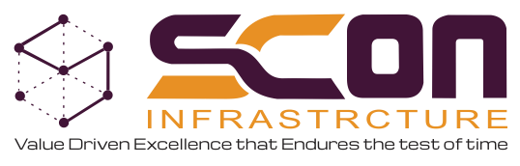
GOLD SPONSOR
S
:

SUPPORT SPONSORS:

OTHER

SPONSORS:

MEDIA PARTNER:

Ref: brochure 2 25-12-2023

